A CRM APPLICATION FOR
THECHAISHOP&CO

User Story:
As a sales executive working at TeaCornerHub, I need a CRM application that can help me efficiently organize and maintain customer information and sales activities.
The application should allow me to easily create, edit, and manage employer, customer, and enterprise records within a centralized platform.
The system should also support differentiation between online and walk-in customers using record types, which will allow better service management.
Additionally, the application must automatically calculate order quantities and total billing amounts to minimize manual errors.
The CRM system should also generate meaningful reports and dashboards to analyze sales performance and customer behavior.
Furthermore, automated email notifications should be sent to customers on special occasions like birthdays to improve engagement and maintain long-term relationships.

1. INTRODUCTION
1.1 Project Overview :
The project titled “CRM Application for TeaCornerHub” focuses on designing and implementing a Salesforce-based customer relationship management system.
This application helps businesses maintain employer accounts, customer data, and enterprise records in a structured and efficient manner.
The system simplifies business operations by automating order processing, billing calculations, and customer communication.
Reports and dashboards generated from the CRM system provide valuable insights for management to analyze business performance and make strategic decisions.
The project user story and objectives are defined in the initial section of the document
1.2 Purpose :
The purpose of this project is to:
●​ Streamline customer relationship management
●​ Automate billing and order calculations
●​ Improve data accuracy
●​ Enable data-driven decision-making
●​ Enhance customer engagement through email automation
2. IDEATION PHASE
2.1 Problem Statement (Customer Problem Statement Template)

Idea ID | Concept Title | Explanation | Expected Benefit
ID1 | Digital Customer Record | Develop a system that stores customer details in a digital format instead of maintaining manual records. | Easy access to customer information
ID2 | Order Tracking Feature | Introduce a feature that records customer orders and maintains order history. | Helps monitor purchase patterns
ID3 | Product Management | Provide functionality to add, edit, or delete tea shop products in the system. | Simplifies product updates
ID4 | Customer Feedback System | Allow customers to submit feedback or suggestions through the system. | Improves service quality
ID5 | Sales Reporting | Generate reports related to daily or monthly sales activities. | Supports better business analysis

2.2 Empathy Map Canvas
Target Users
●​ Sales Representatives
●​ Managers
●​ System Administrators
●​ Business Analysts

Empathy Analysis
Stakeholder | Observations | Needs / Expectations | Possible Solution
Customers | Customers prefer quick service and simple ordering process. | Fast order placement and accurate service. | Implement a system that records orders quickly and efficiently.
Shop Staff | Staff members manage multiple customer requests at the same time. | Easy access to customer and order details. | Provide a CRM interface that allows quick retrieval of information.
Shop Owner | Owner needs to monitor sales and customer activity regularly. | Proper reports and organized data. | Generate automated reports through the CRM system.
Regular Customers | Frequent customers may have specific preferences for products. | Personalized service and order history tracking.

2.3 Brainstorming
Brainstormed Ideas
●​ Manual CRM system
●​ Excel-based management
●​ Web-based CRM
●​ Salesforce-based CRM
●​ Automated email system

3.REQUIREMENT ANALYSIS PHASE
3.1 Customer Journey Map
Journey Stages:
●​ Login
●​ Access CRM Application
●​ Enter Customer Data
●​ Generate Orders
●​ Calculate Bills
●​ View Reports
●​ Decision Making

3.2 Solution Requirements
Functional Requirements

FR No | Requirement
FR-1 | User Login
FR-2 | Object Creation
FR-3 | Data Entry
FR -4 | Billing Automation
FR-5 | Report Generation
FR-6 | Email Automation

Non-Functional Requirements
Non-functional requirements describe the quality attributes and operational characteristics of the CRM system. These requirements focus on how effectively the system performs rather than the specific features it provides.

Requirement Type | Description
Performance | The CRM system should respond quickly when users access customer details, place orders, or generate reports.
Security | The application must ensure that only authorized users can access the system through proper authentication and login mechanisms.
Reliability | The system should operate consistently without frequent failures and must maintain data accuracy during usage.
Usability | The interface should be simple and easy to understand so that shop staff can use the system without difficulty.
Scalability | The system should be capable of handling an increasing number of customers and transactions in the future.
Availability | The application should remain accessible whenever users need to access the system for daily operations.

3.3 Data Flow Diagram
User → Salesforce UI → Custom Objects → Validation Rules → Flows → Reports →
Dashboards.

3.4 Technology Stack
Layer | Technology
Frontend | Salesforce Lightning
Database | Salesforce Cloud
Automation | Flows
Backend | Salesforce Platform
Analytics | Reports&Dashboards

4. PROJECT DESIGN PHASE
4.1 Problem–Solution Fit
The CRM system replaces manual records with automated data management. Cloud
storage prevents data loss, dashboards improve analysis, and real-time reports eliminate
delays. This ensures accurate and timely business insights generation.

4.2 Proposed Solution
Functional Requirements

Requirement ID | Functional Feature | Description | Importance
FR1 | Customer Registration | The system should allow new customers to register and store their basic details such as name, phone number, and address. | High
FR2 | Customer Data Management | The CRM platform should enable staff to view, update, and maintain customer information whenever required. | High
FR3 | Order Tracking | The system should record customer orders and maintain the order history for future reference. | Medium
FR4 | Product Information Management | The platform should allow administrators to add, modify, or remove product details available in the tea shop. | Medium
FR5 | Customer Feedback Handling | Customers should be able to submit feedback or suggestions, which will be stored and reviewed by the management. | Low
FR6 | Sales Report Generation | The system should generate periodic reports related to sales, orders, and customer activity. | High
FR7 | User Authentication | The CRM application should ensure secure login access for authorized users such as staff or admin. | High

4.3 Solution Architecture
Architecture Layers
1.​ Presentation Layer – Lightning UI
2.​ Application Layer – Flows and Logic
3.​ Data Layer – Custom Objects
4.​ Analytics Layer – Reports and Dashboards
This layered architecture ensures modularity, scalability, and maintainability.

5. PROJECT PLANNING & SCHEDULING
5.1 Project Planning
●​ The project followed an Agile-based development approach with defined
milestones and sprints.
●​ A Salesforce Developer account was created to set up the development
environment.
●​ Custom objects were designed to store customer, employer, and enterprise data.
●​ Custom tabs and a Lightning Application were developed for easy system
navigation.
●​ Fields, relationships, and global picklists were configured to ensure data
consistency.
●​ Page layouts and record types were created based on user roles and customer
categories.
●​ Validation rules were implemented to prevent incorrect data entry.
●​ Email templates and automated flows were developed for customer notifications.
●​ Reports and dashboards were created for performance monitoring and analysis.
●​ Regular sprint reviews and testing were conducted to track progress and resolve
issues.
●​ The project was completed within the planned timeline through systematic
scheduling.

Product Backlog, Sprint Schedule, and Estimation
Use the below template to create product backlog and sprint schedule
Sprint | Funcional Requirement (Epic) | User Story Number | User Story / Task | Story Points | Priority | Team Members
Sprint-1 | Developer  Setup | USN-1 | As an admin, I want to create a  Salesforce developer account so  that I can configure and deploy the  TheChaiShop&Co CRM  application. | 1 | High | Manasa
Sprint-1 | Data Modeling | USN-2 | As an admin, I want to create  Customer, Employer, and  Enterprise objects so that business  data can be stored and managed  systematically. | 3 | High | Manasa
Sprint-2 | Data Modeling | USN-3 | As a user, I want separate tabs for  each object so that I can easily  navigate and manage CRM  records within the application. | 3 | High | Apana
Sprint-2 | Data Modeling | USN-4 | As a manager, I want a dedicated  Lightning App so that all CRM  operations are accessible from a  single dashboard. | 3 | High | Apana
Sprint-2 | Data Modeling | USN-5 | As an admin, I want to create  customer and order fields so that  complete sales and billing details  can be captured accurately. | 5 | Medium | Apana
Sprint-2 | Data Modeling | USN-6 | As a user, I want customized page  layouts for different record types so  that only relevant information is  displayed during data entry | 5 | High | Apana
Sprint-2 | Data Modeling | USN-7 | As a manager, I want separate  record types for Retail and  Enterprise customers so that  different business categories can  be managed efficiently. | 5 | Medium | Apana
Sprint-3 | Automation | USN-8 | As a system, I want to validate  customer details and order inputs  so that incorrect data entries are  prevented. | 3 | High | Safreen
Sprint-3 | Automation | USN-9 | As a system, I want automated  flows to send email notifications so  that customers receive timely  updates and offers. | 5 | High | Safreen
Sprint-4 | Automation | USN-10 | As a system, I want to  automatically calculate billing  amounts so that invoices are  generated without manual effort. | 5 | High | Safreen
Sprint-5 | Reports | USN-11 | As a manager, I want sales and  customer reports so that I can  monitor business performance and  make informed decisions. | 4 | High | Baranika
Sprint-6 | Dashboards | USN-12 | As a manager, I want visual  dashboards so that I can quickly  analyze sales, customers, and  enterprise performance. | 4 | Medium | Baranika

6. Project Development Phase:
Project Flow
- Milestone 1 : Creation of developer account
- Milestone 2 : Object Creation
- Milestone 3 : Tabs
- Milestone 4 : The Lightning App
- Milestone 5 : Global Picklist
- Milestone 6 : Fields and Relationships
- Milestone 7 : Creation of Page Layout
- Milestone 8 : Creation of Record Types
- Milestone 9 : Validation rules
- Milestone 10 : Email Templates
- Milestone 11 : Flows
- Milestone 12 : Reports and Dashboards
- Milestone 13 : Conclusion

What you'll learn
1.​ Real Time Salesforce Project
2.​ Standard and Custom objects
3.​ Picklist Value sets
4.​ Types of Fields & their relationships.
5.​ Page Layouts
6.​ Record Types
7.​ Validation Rules
8.​ Email Templates
9.​ Flows
10.​Reports and Dashboards.
Implementation
Milestone 1 - Salesforce developer account creation :
Activity 1: Creating Developer Account:
Creating a developer org in salesforce.
1.​ Go to https://developer.salesforce.com/signup
2.​ On the sign up form, enter the following details :
1)​ First name & Last name
2)​ Email
3)​ Role : Developer
4)​ Company : College or Company Name
5)​ County : India
6)​ Postal Code : pin code
7)​ Username : should be a combination of your name and company
This need not be an actual email id, you can give anything in that format :
username@organization.com
Click on sign me up after filling these.

Activity 2: Account Activation :
1.​ Go to the inbox of the email that you used while signing up. Click on the verify
account to activate your account. The email may take 5-10mins.
2.​ Click on Verify Account.
3.​ Give a password and answer a security question and click on change password.
4.​ Then you will redirect to your salesforce setup page.
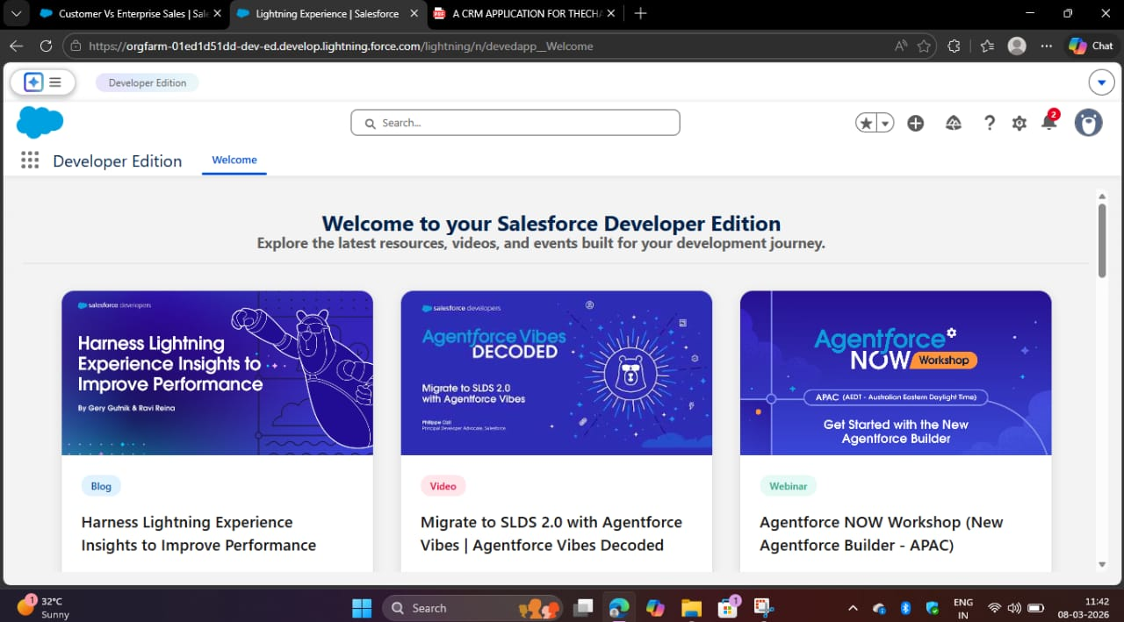

Milestone 2 - Objects
1.​ In your Salesforce org, click gear icon on the top left and select Setup to
open Setup.
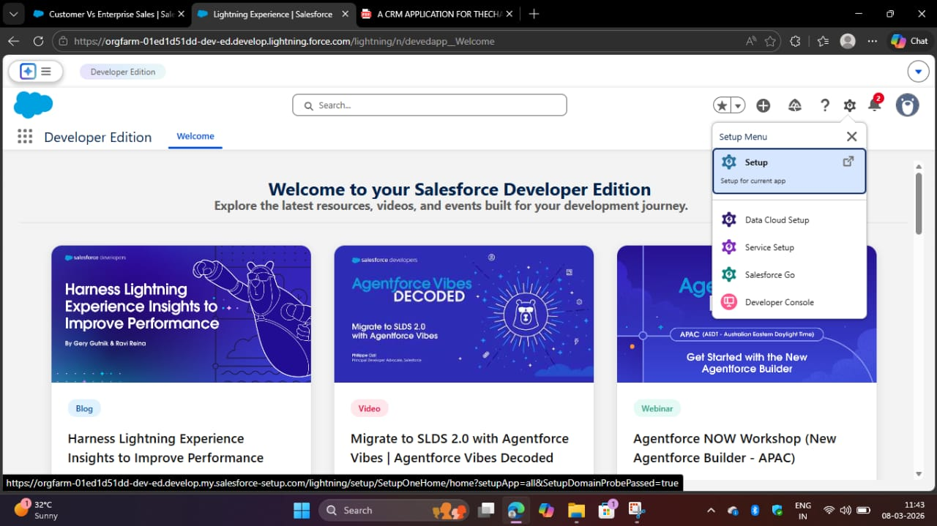
2.​ Click the Object Manager tab. If you don’t see it, enter Object Manager in
the Quick Find box.
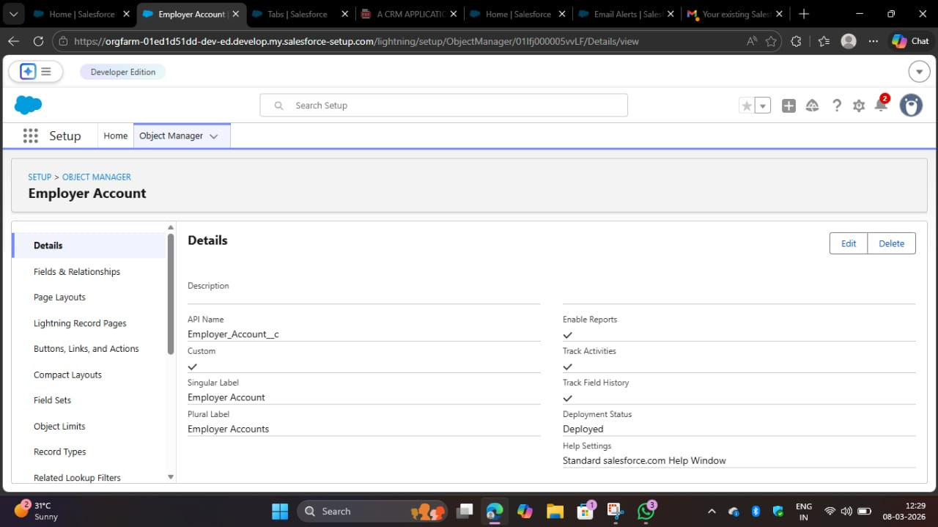

3.​ On the Object Manager page, click Create | Custom Object.

Activity 1 : Employer Account Object​

1.​ From the setup page → Click on Object Manager → Click on Create → Click on
Custom Object.
●​ Label : Employer Account
●​ Plural Label : Employer Accounts
●​ Enter Record Name Label and Format
​Record Name : Employer Account Name
Data Type : Text
●​ In Optional features : check the boxes for Allow Reports | Allow Activities
| Track Field History.
●​ Search Status : check the box for Allow Search.
●​ Save

Activity 2 : Customer Account Object
1.​ From the setup page → Click on Object Manager → Click on Create → Click on
Custom Object.
●​ Label : Customer Account
●​ Plural Label : Customer Accounts
●​ Enter Record Name Label and Format
​Record Name : Customer Account Name
Data Type : Text
●​ In Optional features : check the boxes for Allow Reports | Allow Activities
| Track Field History.
●​ Search Status : check the box for Allow Search.
●​ Save

Activity 3 : Enterprise Account Object
1.​ From the setup page → Click on Object Manager → Click on Create → Click on
Custom Object.
●​ Label : Enterprise Account
●​ Plural Label : Enterprise Accounts
●​ Enter Record Name Label and Format
​Record Name : Enterprise Account Name
Data Type : Text
●​ In Optional features : check the boxes for Allow Reports | Allow Activities
| Track Field History.
●​ Search Status : check the box for Allow Search.
●​ Save

Milestone 3 - Tabs
Activity 1 : Custom tabs creation
1.​ Go to setup page → type Tabs in Quick Find bar → click on tabs → New
(under custom object tab)

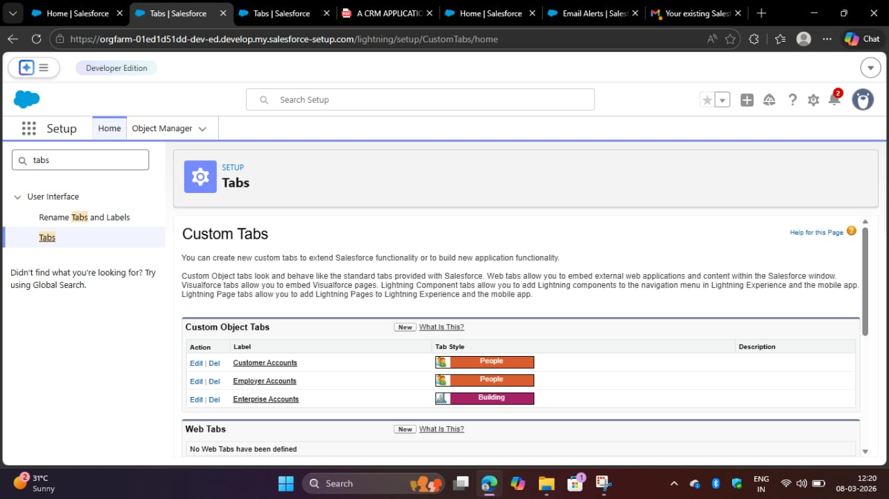
2.​ Select Object(Employer Accounts) → Select the tab style → Next (Add to
profiles page) keep it as default → Next (Add to Custom App) uncheck
the include tab .
3.​ Make sure that the Append tab to users' existing personal customizations
is checked.
4.​ Click save.
5.​ Repeat the same steps for Customer Accounts and Enterprise Accounts.

Milestone 4 - The Lightning App

Activity 1 : Create a lightning app
1.​ Go to setup page → search “app manager” in quick find → select “app manager”
→ click on New lightning App.

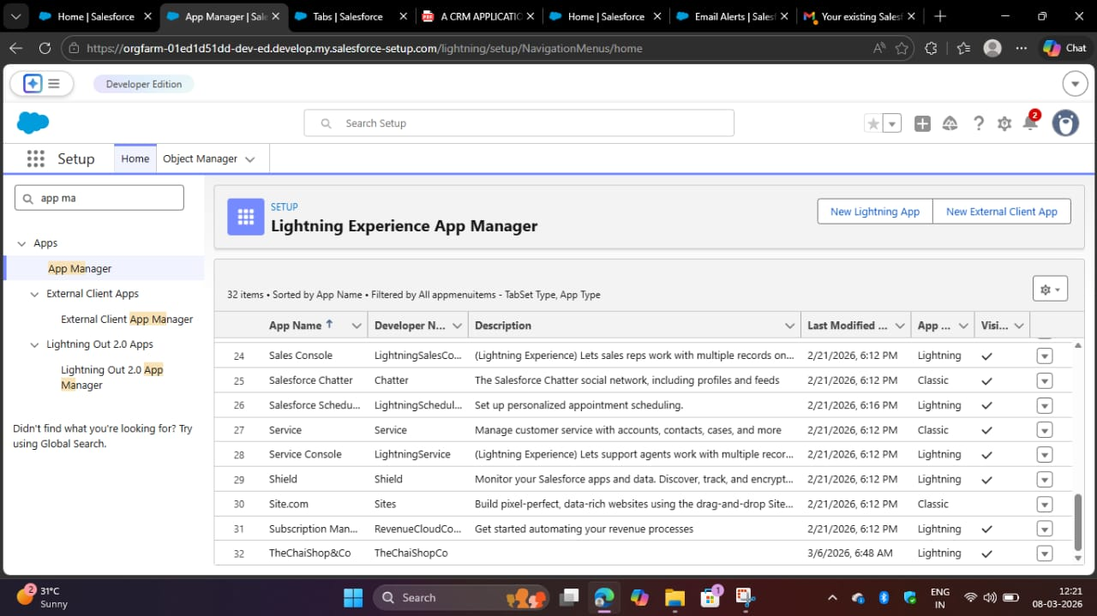

2.​ Fill the app name in app details and branding as follow
App Name : TeaCornerHub
Developer Name : Auto Populates
Add image optional (if you want to give any image you can otherwise not
mandatory) - Add Primary color Hex or leave it to default.
Then click Next.

3.​ In App options
Navigation style : Standard navigation
Setup experience : setup
Supporters form factors : Desktop and phone
Then click Next

4.​ In Utility items
Utility Bar alignment : Default
Then click Next.

5.​ Navigation items
Select the created Custom Objects and required standard objects
●​ Customer Accounts
Employer Accounts
Enterprise Accounts
Reports
Dashboards

6.​ To Add User Profiles : System Administrator
​7.​ Click Save & Finish.

Milestone 5 : Global Picklist
Activity 1 : Create Global PIcklist
1.​ In Quick find box search for : Picklist value sets and click New.
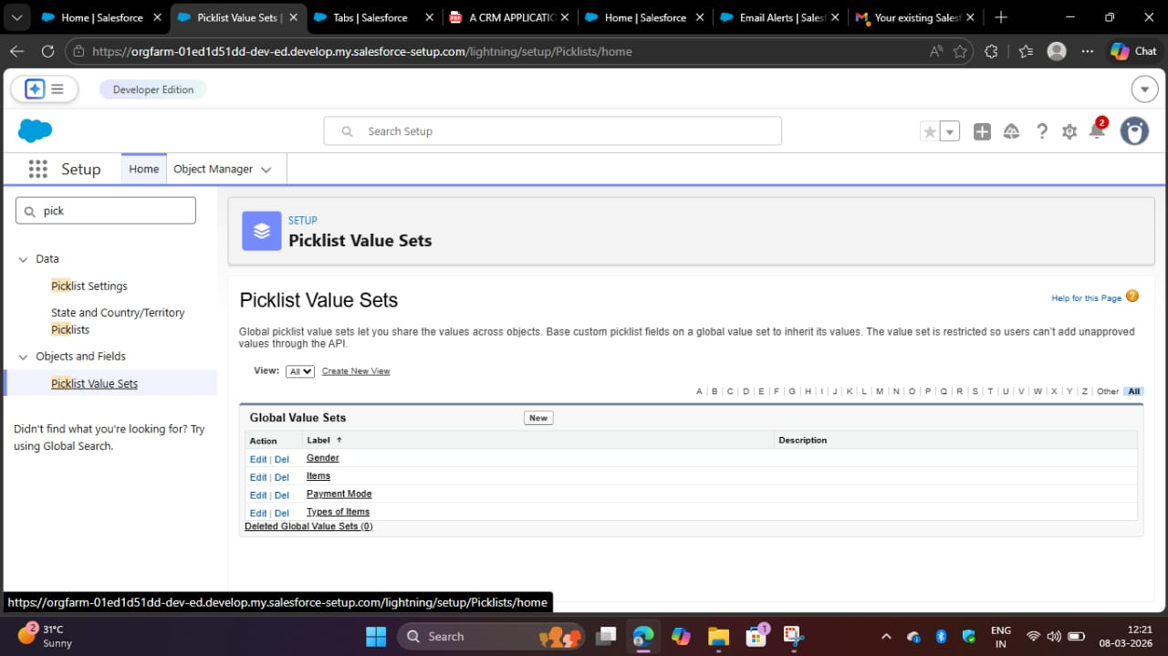

●​ Label : Gender
Name : Auto Populates
Values : Male
Female
Others
Click Save & New.

2.​ Create three more Global picklists following the same steps.
●​ Label : Items
Name : Auto populates
Values : Platinum Tea Powder
Double Delight Tea Powder
Super Dust Tea Powder
Osmania Biscuits (Value Pack)
Osmania Biscuits (Premium Pack)
Dry Fruit Biscuits
Fruit Biscuits
Salt Biscuits
Multigrain Biscuits
Ragi Biscuits
Double Choco Chip Cookies
Butter Almond Cookies
Melting Moments Cookies
Honey Oats Cookies
Delight Box
Signature Box
Assorted Box
​Click Save & New.

●​ Label : Payment Mode
Name : Auto populates
Values : Gpay
PhonePe
Paytm
Credit or Debit card
Cash.
Click Save & New.

●​ Label : Type of Items
Name : Auto populates
Values : Tea powder
Cookies
Gift Hampers
Click Save.

Milestone 6 : Fields & Relationships
Activity 1 : Create Custom fields for Employer Account
1.​ In your Salesforce org, click gear icon on the top left and select Setup to open
Setup.
2.​ Click the Object Manager tab. If you don’t see it, enter Object Manager in the
Quick Find box.
3.​ From the object manager page, In the Quick Find box, Search for the custom
object you just created : Employer Account
4.​ From the sidebar, click Fields & Relationships. Notice that there are already
some fields there. Those are the standard fields.
5.​ Click New to create a custom field. Tip: Before creating a new field, do a quick
search to make sure a similar one doesn’t already exist.

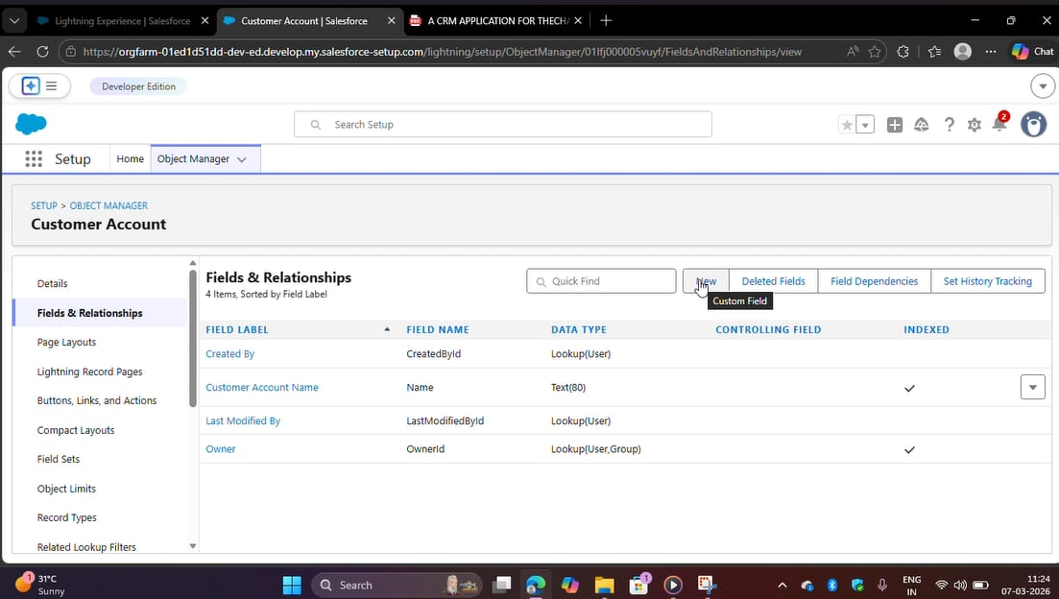
6.​ Next, choose a data type as Text. Choosing a data type helps you format the field
input.
7.​ Click on next.
8.​ Data Type : Text
Field Label: First Name
Field Name : Auto Populates
Length : 25
Required : Check the box
Click on Next → Next → Save and new.

9.​ Repeat the Same steps for remaining fields

●​ Data Type : Text
Field Label: Last Name
Field Name : Auto Populates
Length : 25
Required : Check the box
Click on Next → Next → Save and new.

●​ Data Type : PickList
Field Label: Gender
Values : Use Global Picklist value set and
select Gender from the dropdown menu.
Field Name : Auto Populates.
Required : Check the box
Click on Next → Next → Save and new.
●​ Data Type : Phone
Field Label : Phone Number
Field Name : Auto Populates
Required : Check the box
Click on Next → Next → Save and new.
●​ Data Type : Email
Field Label : Email ID
Field Name : Auto Populates
Required : Check the box
Click on Next → Next → Save and new.

●​ Data Type : Date
Field Label : Date of Birth
Field Name : Auto Populates
Required : check the box
Click on Next → Next → Save and new.
​
●​ Data Type : Text
Field Label : Aadhar Number
Field Name : Auto Populates
Length : 12
Click on Next → Next → Save and new.

●​ Data Type : Text
Field Label : PAN Details
Field Name : PAN_Details
Length : 10
Click on Next → Next → Save and new.

●​ Data Type : Picklist
Field Label : Designation
Field Name : Auto Populates
Value : Enter value, with each value separated by a new line.
Manager
Finance and Accounting
Kitchen Staff
Cashier
Servers
Click on Next → Next → Save and new.

●​ Data Type : Currency
Field Label : Salary
Field Name : Auto Populates
Click on Next → Next → Save.

Activity 2: Create Custom fields for Customer Account
1.​ Data Type : Text
Field Label: First Name
Field Name : Auto Populates
Length : 25
Required : Check the box
Click on Next → Next → Save and new.

2.​ Data Type : Text
Field Label: Last Name
Field Name : Auto Populates
Length : 25
Required : Check the box
Click on Next → Next → Save and new.

3.​ Data Type : PickList
Field Label: Gender
Values : Use Global Picklist value set and
select Gender from the dropdown menu.
Field Name : Auto Populates.
Required : Check the box
Click on Next → Next → Save and new.

4.​ Data Type : Phone
Field Label : Phone Number
Field Name : Auto Populates
Required : Check the box
Click on Next → Next → Save and new.

5.​ Data Type : Date
Field Label : Date of Birth
Field Name : Auto Populates
Required : check the box
Click on Next → Next → Save and new.

6.​ Data Type : Formula
Field Label : Date of Birthday is today ?
Field Name : Auto Populates
Formula Return : Checkbox
Formula :
IF(
AND(
DAY( TODAY() ) = DAY( Date_of_Birth__c ) ,
MONTH ( TODAY()) = MONTH( Date_of_Birth__c )),
TRUE,
FALSE)
Click on Next → Next → Save and new.

7.​ Data Type : Email
Field Label : Email ID
Field Name : Auto Populates
Required : Check the box
Click on Next → Next → Save and new.

8.​ Date Type : Text
Field Label : Address
Field Name : Auto Populates
Length : 125
Click on Next → Next → Save and new.

9.​ Date Type : Multi Select Picklist
Field Label : Type of Items
Values : Use Global Picklist value set and
select Type of Items from the dropdown menu.
Field Name : Auto Populates.
Required : Check the box
Click on Next → Next → Save and new.

10.​Date Type : Multi Select Picklist
Field Label : Products purchased
Values : Use Global Picklist value set and
select Items from the dropdown menu.
Field Name : Auto Populates.
Required : Check the box
Click on Next → Next → Save and new.

11.​ Date Type : Multi Select Picklist
Field Label : Chai
Value : Enter value, with each value separated by a new line.
​TeaCornerHub Special Tea
Single Tea
Masala Tea
Lemon Tea
Ginger Tea
Green Tea
Sugar Free Tea
Click on Next → Next → Save and new.

12.​ Data Type : Picklist
Field Label : Payment Mode
Values : Use Global Picklist value set and
select Payment Mode from the dropdown menu.
Field Name : Auto Populates.
Required : Check the box
Click on Next → Next → Save and new.

13.​ Data Type : Lookup Relationship
Related To : Employer Account
Field Label : Associated Employer
Field Name : Auto Populates
Click on Next → Next → Save and new.
14.​ Data Type : Formula
Field Label : Order Quantity
Field Name : Auto Populates
Formula Return : Number
Enter Formula = Quantity (Number) =
IF(INCLUDES( Products_Purchased__c , "Platinum Tea Powder"), 1, 0 ) +
IF(INCLUDES( Products_Purchased__c , "Double Delight Tea Powder"), 1, 0 ) +
IF( INCLUDES( Products_Purchased__c , "Super Dust Tea Powder") , 1, 0) +
IF(INCLUDES( Products_Purchased__c , "Osmania Biscuits (Value Pack)"), 1, 0 ) +
IF(INCLUDES( Products_Purchased__c , "Osmania Biscuits (Premium Pack)"), 1, 0 ) +
IF( INCLUDES( Products_Purchased__c , "Dry Fruit Biscuits") , 1, 0) +
IF(INCLUDES( Products_Purchased__c , "Fruit Biscuits"), 1, 0 ) +
IF(INCLUDES( Products_Purchased__c , "Salt Biscuits"), 1, 0 ) +
IF(INCLUDES( Products_Purchased__c , "Multigrain Biscuits"), 1, 0 ) +
IF(INCLUDES( Products_Purchased__c , "Ragi Biscuits"), 1, 0 ) +
IF( INCLUDES( Products_Purchased__c ,"Double Choco chip Cookies") , 1, 0) +
IF(INCLUDES( Products_Purchased__c , "Butter Almond Cookies"), 1, 0 ) +
IF(INCLUDES( Products_Purchased__c , "Melting Moments Cookies"), 1, 0 ) +
IF( INCLUDES( Products_Purchased__c , "Honey Oats Cookies") , 1, 0) +
IF(INCLUDES( Products_Purchased__c , "Delight Box"), 1, 0 ) +
IF(INCLUDES( Products_Purchased__c , "Signature Box"), 1, 0 ) +
IF( INCLUDES( Products_Purchased__c , "Assorted Pack") , 1, 0) +
IF(INCLUDES( Chai__c , "TeaCornerHub Special Tea"), 1, 0) +
IF(INCLUDES( Chai__c , "Single Tea"), 1, 0) +
IF(INCLUDES( Chai__c , "Masala Tea"), 1, 0) +
IF(INCLUDES( Chai__c , "Lemon Tea"), 1, 0) +
IF(INCLUDES( Chai__c , "Ginger Tea"), 1, 0) +
IF(INCLUDES( Chai__c , "Green Tea"), 1, 0) +
IF(INCLUDES( Chai__c , "Sugar Free Tea"), 1, 0)
Click on Next → Next → Save and new.

15.​ Data Type : Formula
Field Label : Total Bill
Field Name : Auto Populates
Formula Return : Number
Enter Formula = Quantity (Number) =
IF(INCLUDES( Products_Purchased__c , "Platinum Tea Powder"), 175, 0 ) +
IF(INCLUDES( Products_Purchased__c , "Double Delight Tea Powder"), 150, 0 ) +
IF( INCLUDES( Products_Purchased__c , "Super Dust Tea Powder") , 125, 0) +
IF(INCLUDES( Products_Purchased__c , "Osmania Biscuits (Value Pack)"), 50, 0 ) +
IF(INCLUDES( Products_Purchased__c , "Osmania Biscuits (Premium Pack)"), 80, 0 ) +
IF( INCLUDES( Products_Purchased__c , "Dry Fruit Biscuits") , 110, 0) +
IF(INCLUDES( Products_Purchased__c , "Fruit Biscuits"), 160, 0 ) +
IF(INCLUDES( Products_Purchased__c , "Salt Biscuits"), 110, 0 ) +
IF(INCLUDES( Products_Purchased__c , "Multigrain Biscuits"), 170, 0 ) +
IF(INCLUDES( Products_Purchased__c , "Ragi Biscuits"), 190, 0 ) +
IF( INCLUDES( Products_Purchased__c ,"Double Choco chip Cookies") , 200, 0) +
IF(INCLUDES( Products_Purchased__c , "Butter Almond Cookies"), 110, 0 ) +
IF(INCLUDES( Products_Purchased__c , "Melting Moments Cookies"), 150, 0 ) +
IF( INCLUDES( Products_Purchased__c , "Honey Oats Cookies") , 160, 0) +
IF(INCLUDES( Products_Purchased__c , "Delight Box"), 850, 0 ) +
IF(INCLUDES( Products_Purchased__c , "Signature Box"), 1500, 0 ) +
IF( INCLUDES( Products_Purchased__c , "Assorted Pack") , 600, 0) +
IF(INCLUDES( Chai__c , "TeaCornerHub Special Tea"), 70, 0) +
IF(INCLUDES( Chai__c , "Single Tea"), 50, 0) +
IF(INCLUDES( Chai__c , "Masala Tea"), 60, 0) +
IF(INCLUDES( Chai__c , "Lemon Tea"), 40, 0) +
IF(INCLUDES( Chai__c , "Ginger Tea"),55, 0) +
IF(INCLUDES( Chai__c , "Green Tea"), 45, 0) +
IF(INCLUDES( Chai__c , "Sugar Free Tea"), 55, 0)
​Click on Next → Next → Save.

Activity 3: Create Custom fields for Enterprise Account
1.​ Data Type : Text
Field Label: Enterprise Name
Field Name : Auto Populates
Length : 25
Required : Check the box
Click on Next → Next → Save and new.

2.​ Data Type : Phone
Field Label : Phone Number
Field Name : Auto Populates
Required : Check the box
Click on Next → Next → Save and new.

3.​ Data Type : Email
Field Label : Email ID
Field Name : Auto Populates
Required : Check the box
Click on Next → Next → Save and new.

4.​ Date Type : Text
Field Label : Address
Field Name : Auto Populates
Length : 125
Click on Next → Next → Save and new.
5.​ Date Type : Multi Select Picklist
Field Label : Type of Items
Values : Use Global Picklist value set and
select Type of Items from the dropdown menu.
Field Name : Auto Populates.
Required : Check the box
Click on Next → Next → Save and new.

6.​ Date Type : Multi Select Picklist
Field Label : Products purchased
Values : Use Global Picklist value set and
select Items from the dropdown menu.
Field Name : Auto Populates.
Required : Check the box
Click on Next → Next → Save and new.

7.​ Data Type : Lookup Relationship
Related To : Employer Account
Field Label : Associated Employer
Field Name : Auto Populates
Click on Next → Next → Save and new.

8.​ Data Type : Formula
Field Label : Order Quantity
Field Name : Auto Populates
Formula Return : Number
Enter Formula = Quantity (Number) =
​IF(INCLUDES( Products_Purchased__c , "Platinum Tea Powder"), 1, 0 ) +
IF(INCLUDES( Products_Purchased__c , "Double Delight Tea Powder"), 1, 0 ) +
IF( INCLUDES( Products_Purchased__c , "Super Dust Tea Powder") , 1, 0) +
IF(INCLUDES( Products_Purchased__c , "Osmania Biscuits (Value Pack)"), 1, 0 ) +
IF(INCLUDES( Products_Purchased__c , "Osmania Biscuits (Premium Pack)"), 1, 0 ) +
IF( INCLUDES( Products_Purchased__c , "Dry Fruit Biscuits") , 1, 0) +
IF(INCLUDES( Products_Purchased__c , "Fruit Biscuits"), 1, 0 ) +
IF(INCLUDES( Products_Purchased__c , "Salt Biscuits"), 1, 0 ) +
IF(INCLUDES( Products_Purchased__c , "Multigrain Biscuits"), 1, 0 ) +
IF(INCLUDES( Products_Purchased__c , "Ragi Biscuits"), 1, 0 ) +
IF( INCLUDES( Products_Purchased__c ,"Double Choco chip Cookies") , 1, 0) +
IF(INCLUDES( Products_Purchased__c , "Butter Almond Cookies"), 1, 0 ) +
IF(INCLUDES( Products_Purchased__c , "Melting Moments Cookies"), 1, 0 ) +
IF( INCLUDES( Products_Purchased__c , "Honey Oats Cookies") , 1, 0) +
IF(INCLUDES( Products_Purchased__c , "Delight Box"), 1, 0 ) +
IF(INCLUDES( Products_Purchased__c , "Signature Box"), 1, 0 ) +
IF( INCLUDES( Products_Purchased__c , "Assorted Pack") , 1, 0)
Click on Next → Next → Save and new.

9.​ Data Type : Formula
Field Label : Total Bill
Field Name : Auto Populates
Formula Return : Number
Enter Formula = Quantity (Number) =
IF(INCLUDES( Products_Purchased__c , "Platinum Tea Powder"), 175, 0 ) +
IF(INCLUDES( Products_Purchased__c , "Double Delight Tea Powder"), 150, 0 ) +
IF( INCLUDES( Products_Purchased__c , "Super Dust Tea Powder") , 125, 0) +
IF(INCLUDES( Products_Purchased__c , "Osmania Biscuits (Value Pack)"), 50, 0 ) +
IF(INCLUDES( Products_Purchased__c , "Osmania Biscuits (Premium Pack)"), 80, 0 ) +
IF( INCLUDES( Products_Purchased__c , "Dry Fruit Biscuits") , 110, 0) +
IF(INCLUDES( Products_Purchased__c , "Fruit Biscuits"), 160, 0 ) +
IF(INCLUDES( Products_Purchased__c , "Salt Biscuits"), 110, 0 ) +
IF(INCLUDES( Products_Purchased__c , "Multigrain Biscuits"), 170, 0 ) +
IF(INCLUDES( Products_Purchased__c , "Ragi Biscuits"), 190, 0 ) +
IF( INCLUDES( Products_Purchased__c ,"Double Choco chip Cookies") , 200, 0) +
IF(INCLUDES( Products_Purchased__c , "Butter Almond Cookies"), 110, 0 ) +
IF(INCLUDES( Products_Purchased__c , "Melting Moments Cookies"), 150, 0 ) +
IF( INCLUDES( Products_Purchased__c , "Honey Oats Cookies") , 160, 0) +
IF(INCLUDES( Products_Purchased__c , "Delight Box"), 850, 0 ) +
IF(INCLUDES( Products_Purchased__c , "Signature Box"), 1500, 0 ) +
IF( INCLUDES( Products_Purchased__c , "Assorted Pack") , 600, 0)
10.​Data Type : Picklist
Field Label : Payment Mode
Values : Use Global Picklist value set and
select Payment Mode from the dropdown menu.
Field Name : Auto Populates.
Required : Check the box
Click on Next → Next → Save.

Milestone 7 : Page Layouts
For the personalized field view in Customer Accounts, let's create two page layouts
Online orders and Walk-In orders.
Activity 1: Online Orders page layout
1.​ Go to the setup page → click on object manager → From drop down click edit for
Customer Account object.
2.​ Click on the Page Layouts → click New.

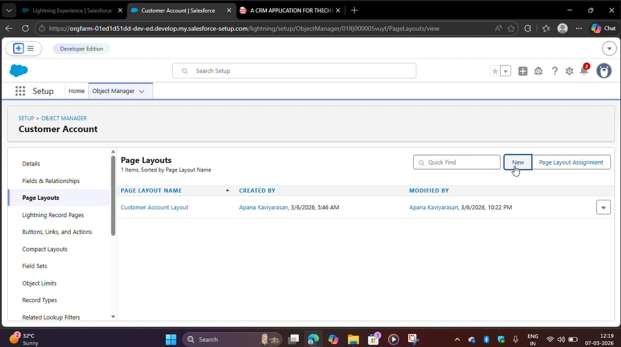
3.​ Page Layout Name : Online Orders and click Save.
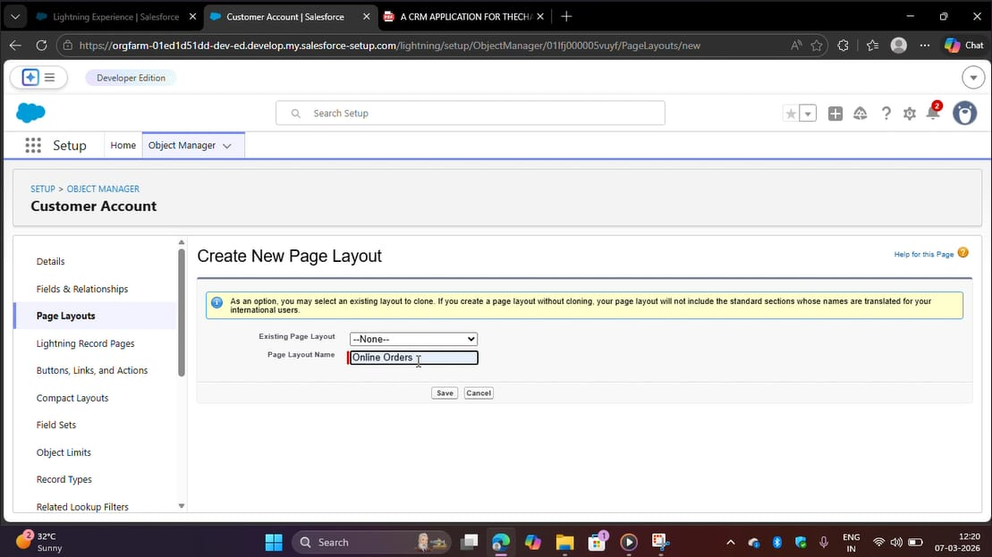

4.​ Drag and Arrange all the required fields as shown below.
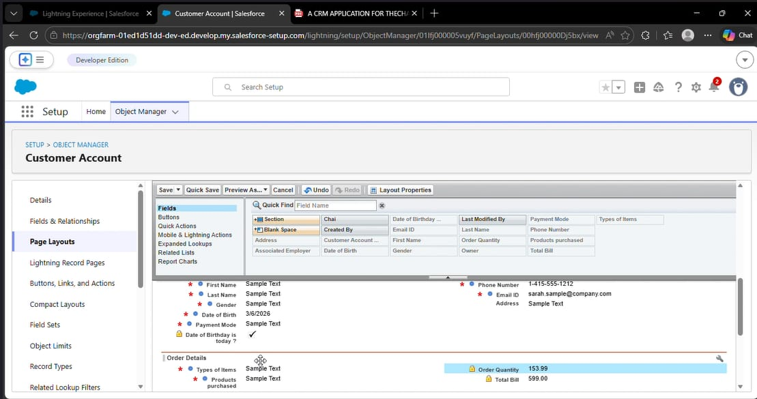

5.​ Click Save.

Activity 2: Walk-In Orders page layout

1.​ Go to the setup page → click on object manager → From drop down click edit for
Customer Account object.
2.​ Click on the Page Layouts → click New.
3.​ Page Layout Name : Walk-In orders and click save.
4.​ Drag and Arrange all the required fields as shown below.
5.​ Click Save.

Milestone 8 - Record Types
To Differentiate the records and data stored in Customer Accounts, let's create two
different Record Types.
Online orders and Walk-In orders.
Activity 1: Online Orders Record Type
1.​ Go to the setup page → click on object manager → From drop down click edit for
Customer Account object.
2.​ Click on the Record Types → click New.

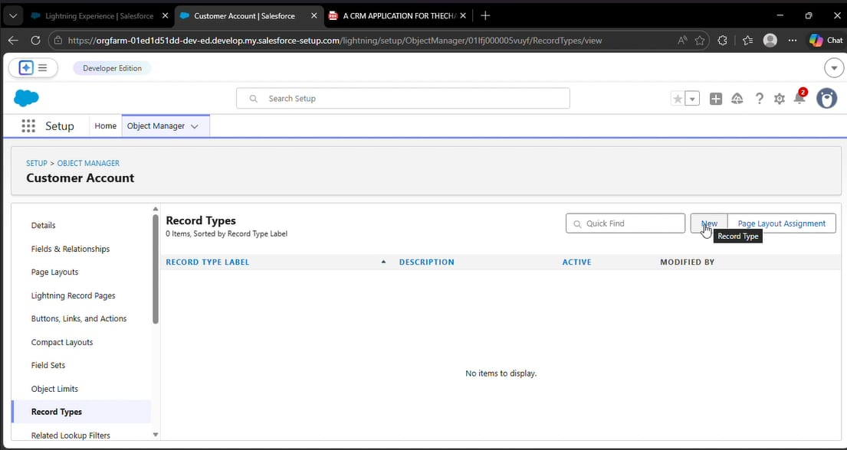
3.​ Enter Details :
Existing Record Type : Master
Record Type Label : Online Order
Record Type Name : Auto Populates
Active : Tick the checkbox
Click Next
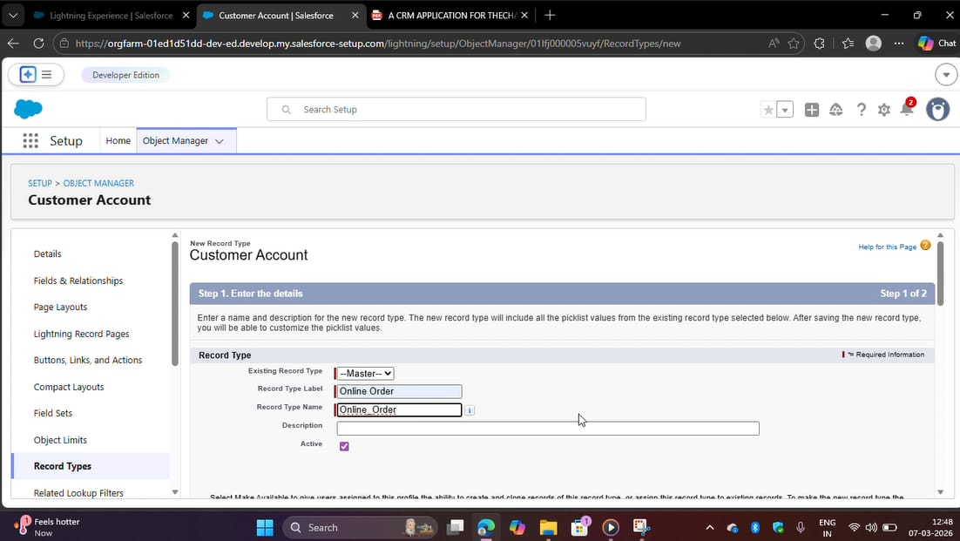
4.​ In Assign Page Layouts
●​ Select Apply one layout to all profiles : select Online orders from the drop
down menu.
5.​ Click Save and New.

Activity 2: Walk-In Orders Record Type
1.​ Go to the setup page → click on object manager → From drop down click edit for
Customer Account object.

2.​ Click on the Record Types → click New.

3.​ Enter Details :
Existing Record Type : Master
Record Type Label : Walk-In Order
Record Type Name : Auto Populates
Active : Tick the checkbox
Click Next

4.​ In Assign Page Layouts
●​ Select Apply one layout to all profiles : select Walk-In orders from the
drop down menu.

5.​ Click Save.

Milestone 9 - Validation Rules
Activity 1: On Employer Account
1.​ Go to the setup page → click on object manager → From drop down click edit for
Employer Account object.

2.​ Click on the validation rule → click New.

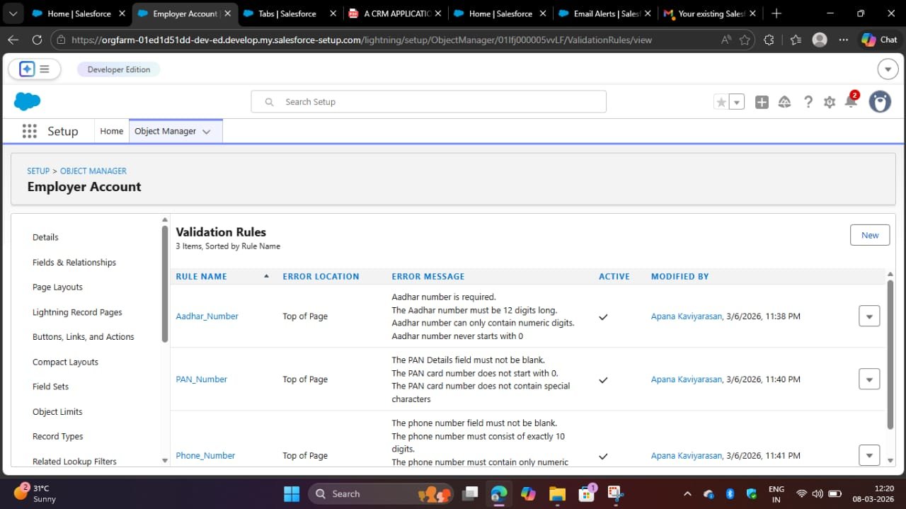
3.​ Enter Rule Name : Aadhar Number
Error Condition Formula :
AND(
NOT(ISBLANK( Aadhar_Number__c )),
LEN( Aadhar_Number__c ) <> 12,
NOT(REGEX( Aadhar_Number__c , "^[1-9]{12}$"))
)
4.​ Error Message : Aadhar number is required.
The Aadhar number must be 12 digits long.
Aadhar number can only contain numeric digits.
Aadhar number never starts with 0

5.​ Click Save & New.

6.​ Repeat the same steps and create two more validation rules on the employer
account object.
●​ Enter Rule Name : PAN Number
Error Condition Formula :
AND(
NOT(ISBLANK( Phone_Number__c )),
NOT(REGEX( Phone_Number__c , "^[1-9]{10}$")),
NOT(REGEX( Phone_Number__c , "^\\d+$"))
)

Error Message : The PAN Details field must not be blank.
The PAN card number does not start with 0.
The PAN card number does not contain special characters.
Click Save & New.

●​ Enter Rule Name : Phone Number
Error Condition Formula :
​AND(
NOT(ISBLANK( Phone_Number__c )),
NOT(REGEX( Phone_Number__c , "^[1-9]{10}$")),
NOT(REGEX( Phone_Number__c , "^\\d+$"))
)
Error Message :
The phone number field must not be blank.
The phone number must consist of exactly 10 digits.
The phone number must contain only numeric digits
(no spaces, dashes, parentheses, etc.)
Click Save.

Activity 2: On Customer Account

1.​ Go to the setup page → click on object manager → From drop down click edit for
Customer Account object.

2.​ Click on the validation rule → click New.

3.​ Enter Rule Name : Phone Number
Error Condition Formula :
​AND(
NOT(ISBLANK( Phone_Number__c )),
NOT(REGEX( Phone_Number__c , "^[1-9]{10}$")),
NOT(REGEX( Phone_Number__c , "^\\d+$"))
)
Error Message :
The phone number field must not be blank.
The phone number must consist of exactly 10 digits.
The phone number must contain only numeric digits
(no spaces, dashes, parentheses, etc.)

4.​ Click Save.

Activity 3: On Enterprise Account
1.​ Go to the setup page → click on object manager → From drop down click edit for
Customer Account object.

2.​ Click on the validation rule → click New.
3.​ Enter Rule Name : Phone Number
Error Condition Formula :
AND(
NOT(ISBLANK( Phone_Number__c )),
NOT(REGEX( Phone_Number__c , "^[1-9]{10}$")),
NOT(REGEX( Phone_Number__c , "^\\d+$"))
)
Error Message :
The phone number field must not be blank.
The phone number must consist of exactly 10 digits.
The phone number must contain only numeric digits
(no spaces, dashes, parentheses, etc.)

4.​ Click Save.

Milestone 10 - Email Template
Activity 1: Email Template
1.​ Go to setup, In quick find box enter Email template → click on classic Email
Template.

2.​ Click on→ New Email Template

3.​ Choose the type of email template you would like to create : Text and click Next.
●​ Available Merge Fields
Select Field Type : Customer Accounts Fields
Select Field : First Name
Copy Merge Field value : Auto Populates, Copy the value and paste it in
the email body where required.

4.​ Folder : Unfiled public Classic Email templates
5.​ Click on available for use
6.​ Email Template Name is “Birthday Offer Email”
7.​ Template Unique Name : Auto populated
8.​ Subject : Special Birthday Offer Inside!
9.​ Email body :
Dear {!Customer_Account__c.First_Name__c},
Happy Birthday from all of us at TeaCornerHub! 🎉🎂 We hope your special day is filled with joy, laughter, and wonderful memories.
To celebrate your birthday, we have a special gift just for you! As a token of our appreciation for your continued support, we're delighted to offer you an exclusive birthday discount.
Birthday Offer: Enjoy a fantastic 50% off on your next purchase as our birthday gift to you!
This offer is our way of saying thank you for being a valued customer. Simply use the code [HBDAY50] at checkout to redeem your birthday treat.
We hope this special offer adds a little extra sparkle to your birthday celebrations!
Once again, happy birthday! Thank you for choosing TeaCornerHub! and being part of our community.
Warm regards
TheChaiShop&Co!
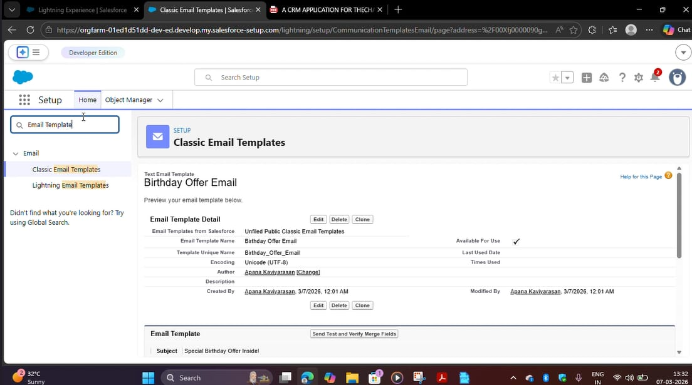
10.​Click Save.

Activity 2: Email Alert
1.​ Go to setup, In quick find box enter Email Alert → click on Email Alert .
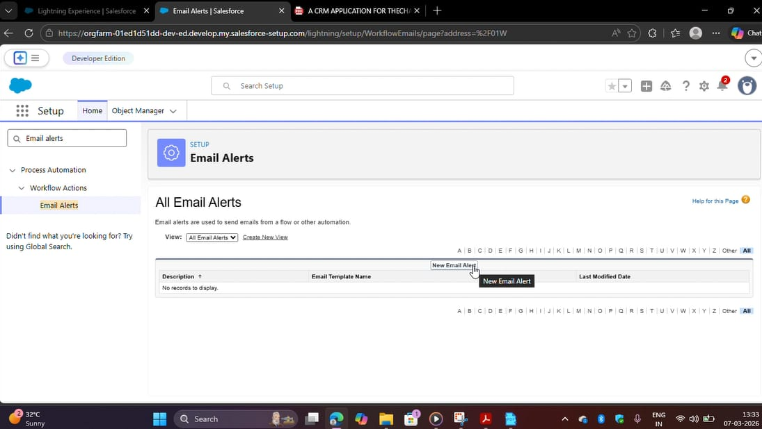

2.​ Click on New Email Alert.
3.​ Description : Happy Birthday email alert
Unique Name : Auto Populates
Object : Customer Account
Email Template : Search for Birthday Offer Email
Recipient Type : Search : Email field : Email ID
From Email Address : Default Workflow user’s email address
Click Save.

NOTE :
1.​ Make sure that the Default workflow user is assigned.

Milestone 11 - Flows
Let’s create a scheduled Triggered flow to automate the Birthday offer mails.
Activity 1: Schedule Triggered Flow
1.​ Go to setup, Type Flow in quick find box → Click on the Flow and Select the
New Flow.
2.​ Select Schedule - Triggered Flow and click Create.

3.​ Set a Schedule
Start Date : Enter the Date, when you want to start the flow.
Start Time : Enter the Time, when you want to start the flow.
Frequency : Daily

4.​ Create Object
Object : Customer Account
Condition Requirements : All conditions Are Met (AND)
●​ Field : Date_of_Birthday_is_today__c
Operator : Equals
Value : $GlobalConstant.True
●​ Field : Email_ID_c
Operator : IS NULL
Value : $GlobalConstant.False

5.​ Click (+) Icon on the flow builder and Select Action Component.

6.​ In New Action Page
Filter By : Type and select Email Alert
In Action : Search and select Happy Birthday email alert
Label : Send Happy Birthday Email
API Name : Auto Populates
Set Input Values for the Selected Action : Record ID : {!$Record.Id}
7.​ Click Done.

8.​ Click Save on the top right
Flow Label : Happy Birthday Email Flow
Flow API Name : Auto Populates
Click Save.

9.​ Click Activate.

Milestone 12 - Reports & Dashboards
Activity 1: Customer Account Sales Report
1.​ Click App Launcher and select TeaCornerHub.
2.​ Click Reports
3.​ Click New Report
4.​ In search type Customer Accounts and Select Customer Accounts.
5.​ Click Start Report.
6.​ Click the toggle Update Preview Automatically to ON.
7.​ Drag and Drop all the required Columns from the Outline pane.
8.​ Group Rows : Search and Select
Customer Account: Record Type
9.​ Click Add Chart on the top.
10.​Click Save on the top right.
Enter
Report Name: Customer Account Sales Report
Report Unique Name : Auto Populates
Click Save.

Activity 2: Enterprise Account Sales Report
1.​ Repeat the same steps to create another report.
2.​ Click Reports
3.​ Click New Report
4.​ In search type Enterprise Accounts and Select Enterprise Accounts.
5.​ Click Start Report.
6.​ Click the toggle Update Preview Automatically to ON.
Drag and Drop all the required Columns from the Outline pane.
Group Rows : Search and Select
Type of Items.
7.​ Click Add Chart on the top.
8.​ Click Save on the top right.
a.​ Enter
b.​ Report Name : Enterprise Account Sales Report
c.​ Report Unique Name : Auto Populates
d.​ Click Save.

Activity 3: Dashboard
1.​ Click Dashboards
2.​ Click New Dashboards
3.​ Name : Customer Vs Enterprise Sales
4.​ Click Create.
5.​ Click Widget
6.​ Select Chart or Table.
7.​ Select Customer Account Sales Report
8.​ Display As : Select the one which you feel comfortable with.
9.​ Click Add.
10.​ Repeat the same steps for the Enterprise Account Sales Report.
11.​Click Save.
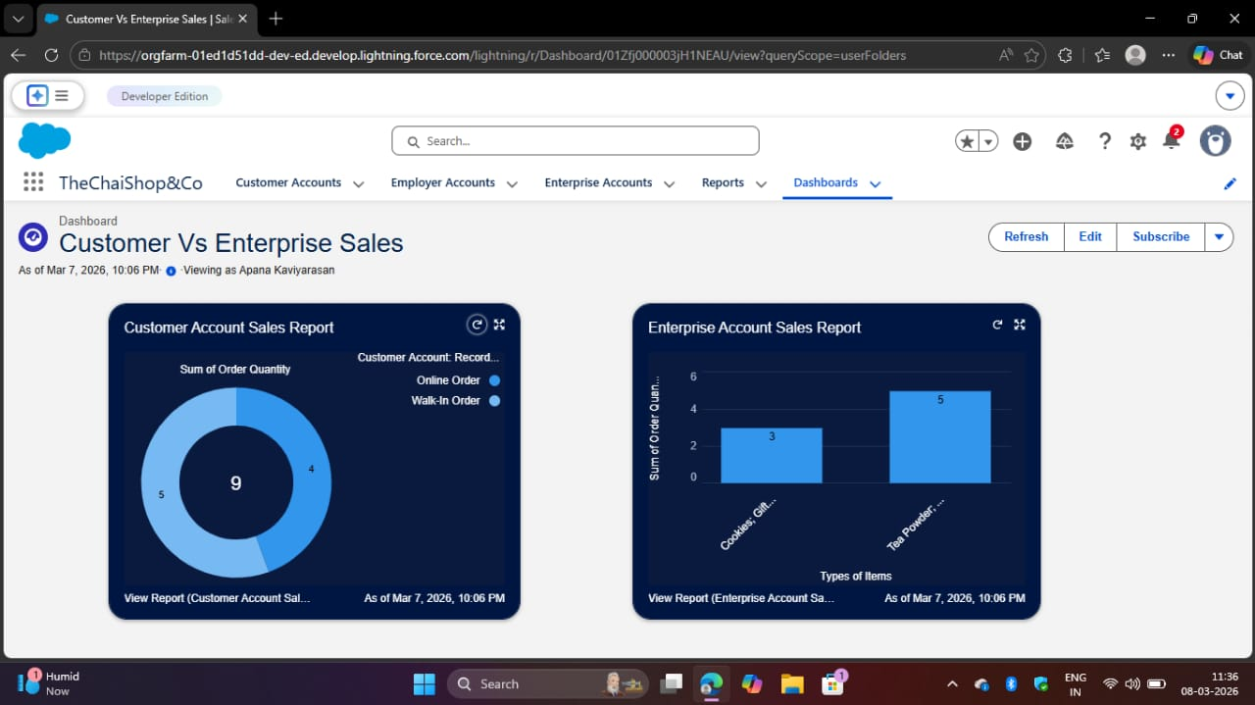

Milestone 12 - Conclusion
In conclusion, the development of TeaCornerHub CRM application marks a
significant stride in enhancing the store's operational efficiency and customer
relationship management capabilities. Seamlessly integrating employer details,
customer information (both online and offline), and enterprise data, this application
streamlines business processes and enables informed decision-making. The
automation of sales calculations, including order quantity and total bill amount, reduces
errors and empowers employees to focus on delivering exceptional service. Moreover,
automated email notifications for customers' birthdays foster personalized
communication and enhance customer engagement.

7. FUNCTIONAL & PERFORMANCE TESTING
During the testing phase, screenshots were captured from the Salesforce Lightning
interface to verify correct system behavior. These include:
●​ Record creation for Employer, Customer, and Enterprise objects
●​ Validation rule testing for Aadhar, PAN, and phone numbers
●​ Verification of record types and page layouts
●​ Formula field validation for order quantity and billing
●​ Flow execution for birthday email alerts
●​ Report and dashboard generation

8. ADVANTAGES & DISADVANTAGES
Advantages
●​ Centralized data management
●​ Reduced manual work
●​ Automated calculations
●​ Improved customer engagement
●​ Real-time analytics
Disadvantages
●​ Requires Salesforce license
●​ Internet dependency
●​ Limited offline access

9. Conclusion:
The CRM Application for TeaCornerHub successfully improves business operations
by integrating customer data, automating billing, and enabling intelligent reporting. The
system reduces errors, saves time, and enhances customer relationships through
automation and analytics.

10. FUTURE SCOPE
●​ Mobile CRM integration
●​ AI-based sales prediction
●​ WhatsApp/SMS alerts
●​ Inventory management
●​ Multi-branch support
●​ Advanced customer profiling

11. APPENDIX
Source Code : Salesforce Configuration & Flows
Dataset : Customer and Sales Records
Tools Used : Salesforce Developer Org

Thank You

